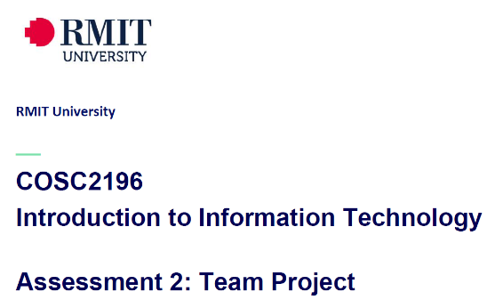 **A2, Group #4 MEETING**

**Venue:** Online via MS Teams

**Date: 6-4-21**

**Minutes**

**Meeting Opened:** 8.05pm

**Attendance:** Paul Eccarius, Rebecca Watson, Martin Lee, Jarrad Hofman-Agar

**Apologies:** Nour Zeroual

**Meeting Chair:** Martin Lee

**Minutes Secretary:** Rebecca Watson

1. **Minutes from previous Meeting -**

* **Actions arising as per Action Register**

1. **Correspondence:**

5-4-21 – Umera has responded to Bec via email with the following:  
Did you receive any response from Anthony Middleton?  
Can you forward me the copy of email you sent out to him?  
Kind Regards,  
Umera

Bec has replied by forwarding email again to Umera sent on 29-3-21 to Anthony and advising no response from this person to the group.

1. **Project Ideas**

* The tinder/swiping angle in Martin’s project ideas is what differentiates it from some other apps already offering similar pet services.
* It can be more of a matching service for pet sitting and people who are going away for a short term, to match with someone who is wanting to look after a dog for a short time (in their area).
* Could include a blue tick to show private sitters vs. kennels or boarding centres.
* Jarrad likened it to auto tempest – put your zip code in and collates all information from across a range of websites, similar to booking.com/trivago.
* We need to submit a design document and user interface pictures to expand on the project idea from assignment 1.
* Feedback for each of us from A1 on our project ideas may help to support our direction. At this stage, Doggy Daycare/Uber/Tinder is the front runner pending A1 feedback.
* Paul has added a question to the Canvas discussion board on how much is expected to be delivered on tangible project idea/s for this A2.
* Jarrad also added a possible idea of a car parts website/app that finds the parts you need. Challenges to feasibility to achieving this idea this semester.

**Next meeting date: 9-4-21 at 8pm**

**Meeting closed: 9pm**

**Actions Register**

|  |  |  |  |  |  |
| --- | --- | --- | --- | --- | --- |
| **Meeting Date** | **Action** | **Who to action** | **Completed Y/N** | **Update at meeting** | **Further action** |
| 31/3/21 | Team Name! | Everyone | Yes | 9/4/21 | Team_Name_404 is the winner. |
| 31/3/21 | Profile & IT Jobs Collation | Rebecca | Draft Complete | 9/4/21 | Put profile photos in report (to match website) |
| 31/3/21 | Github & Archiving | Paul | In hand, ongoing | 9/4/21 | Framework is there, Paul to finalise content as it is completed |
| 31/3/21 | Interview Questions & Appointment | Nour | Need update- ask Nour how she is going with it | 9/4/21 | Interview to be done as a group within the next week and a half. Question template on Canvas. |
| 31/3/21 | Industry Information – Revist on 6/4/21 | Jarrad | Ongoing | 9/4/21 | Jarrad to work on when his new computer arrives, will let the team know if he needs assistance. Using information from our ideal jobs section. |
| 31/3/21 | IT Technologies Report:    Martin: Cybersecurity  Rebecca: Cloud Services  Nour: Machine Learning  Paul: Raspberry Pi etc. | Team | **Martin**: should be complete by tomorrow and uploaded to teams.  **Paul**: to be completed.  **Bec**: Report is done by currently a few too many words.  **Nour**: need update | 9/4/21 | Reports to be completed by end of this week and uploaded to MS Teams & Github/website. |
| 31/3/21 | Project Ideas | Team | Ongoing - See discussion in minutes. | 9/4/21 | Team members are going to wait to see their feedback and marks from A1 to decide on final project – decision to be made at next meeting. |

**Link to recording of meeting** [**https://web.microsoftstream.com/video/32171fd6-2ad9-4061-889b-99bb2f57b04b**](https://web.microsoftstream.com/video/32171fd6-2ad9-4061-889b-99bb2f57b04b)